**Period : 10/11th Sept,2019**

**Pax : 4pax+1CNB**

**Hotel : 4**** or similar**

**Meal : normal meals**

**4D3N Jinan-Qufu-Taian TOUR**

**D1: Jinan (-/L/D) By Bullet Train**

Arrived in **Jinan**, visit **Daming Lake,Qushuiting Street,Black Tiger Spring, Furong Street.** After dinner, go to hotel have a rest.

**D2: Jinan-Qufu(by coach for 2H)-Taian (B/L/D)(by coach for 1H)**

Hotel breakfast,transfer to **Qufu,**visit **Confucius Mansion,Confucius Temple,Wanqi Palace Wall**,afternoon,transfer to **Taian**,visit **Dai Miao Temple Scenic Spot**,after dinner,then go to hotel for rest.

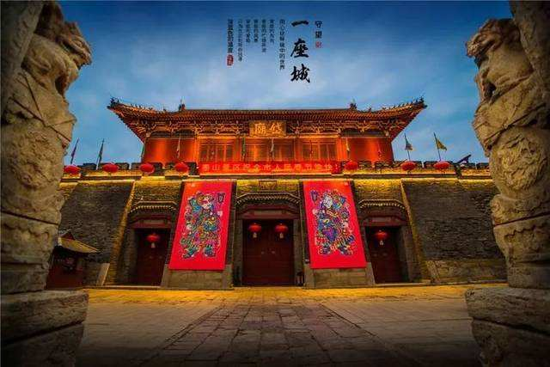

**D3: Tai’an-Jinan(B/L/D)(by coach for 1.5H)**

After Breakfast in the hotel, visit **Taishan Mountain(include Cable way up and down),Nan Tian Men,Tian Jie,Jade emperor Ding**,then transfer to Jinan**,** visit **Baotu Spring,Spring City Square,**after dinner,go to hotel for rest.

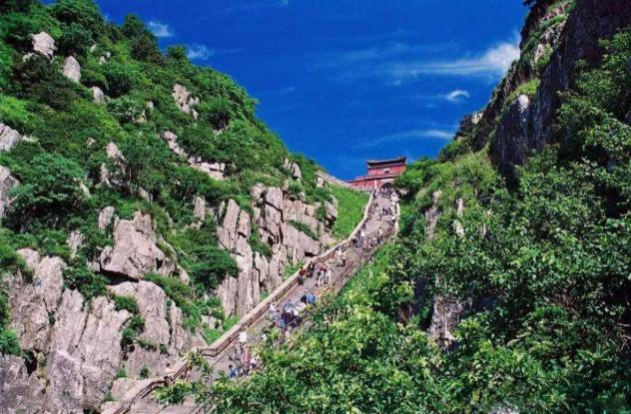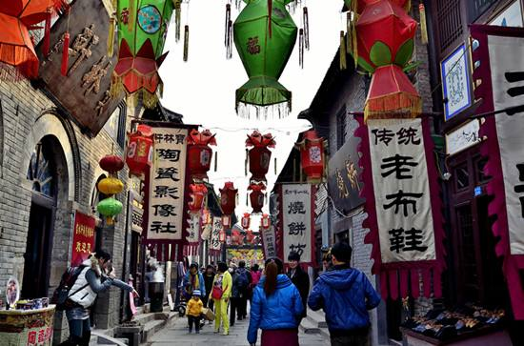

**D4:** **Jinan(B)**

After Breakfast in the hotel, transfer to Train Station**.**

**Hotel 4****local or similar**

**Jinan:Inzone Garland Hotel Jinan or similar**[**https://hotels.ctrip.com/hotel/455117.html#ctm_ref=www_hp_bs_lst**](https://hotels.ctrip.com/hotel/455117.html#ctm_ref=www_hp_bs_lst)

**Taian:Inzone Garland Hotel or similar**

[**https://hotels.ctrip.com/hotel/967998.html#ctm_ref=www_hp_bs_lst**](https://hotels.ctrip.com/hotel/967998.html#ctm_ref=www_hp_bs_lst)

|  |  |  |  |  |
| --- | --- | --- | --- | --- |
| **PAX** | **4 STAR (per pax)** | | | |
| **TWN（USD）** | **SGL SUPL（USD）** | **CWB(USD)** | **CNB(USD)** |
| **4+1child** | **460/pax** | **90** | **460** | **345** |

**The above quotation included:**

1. Transfer in/out

2. **Meals *6 +3 Breakfast**

3. English speaking guide and entrance fee

4. Accommodate in 4 star hotel

5. Free 1 Bottle of water /Pax/day

**The above quotation excluded:**

1. International flight ticket and airport tax

**2. Tips for the guide and driver $8/pax/day.**

3. Tips for potter, waitress & Luggage’s fee

4. Personal consumption & expenses (laundry, phone, mini bar, etc)

5.Accident Insurance

REMARKS

* The sequence of the tour program may be re-arranged by local tour operators as deemed necessary

* FOC is only for Tour Leader. Tour Leader without professional leader card can’t get fully free of charge. Need to pay entrance fee and another needed expense by her/himself.

* Price is not available at Chinese National Holiday/Festival or big events (negotiable)

* Price can be change depends on situations, conditions & terms (negotiable)

* Price of the flight can be change depends on situation (negotiable)

* The above rates are unavailable for groups of students, university, travel agent family / staff, airline staffs